<https://github.com/KaedenOndrus/CIS310-Assigment2>

Register File:

I created two read ports by having two separate multiplexers with two separate selector pins so that two registers can be read from at once. There is one write selector with one input for writing data, so that only one register can be written to at a time.

Test: Writing to and reading from two registers:

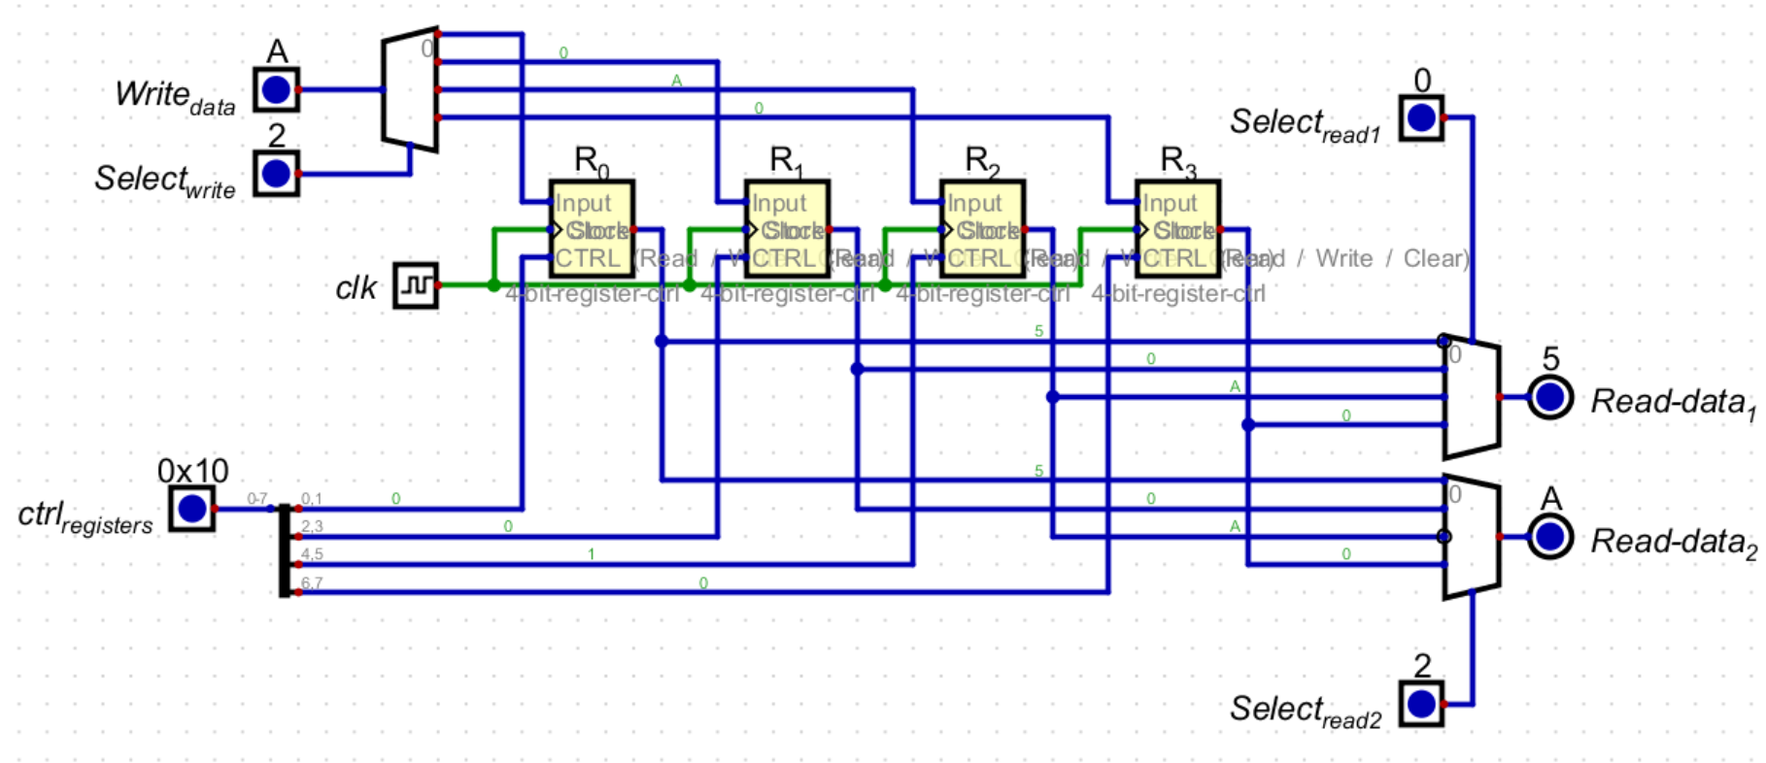

ALU:

Arithmetic operations can be selected by changing the carry in input and the two selection bits. Specific examples of usage can be seen below.

Test 1: Add

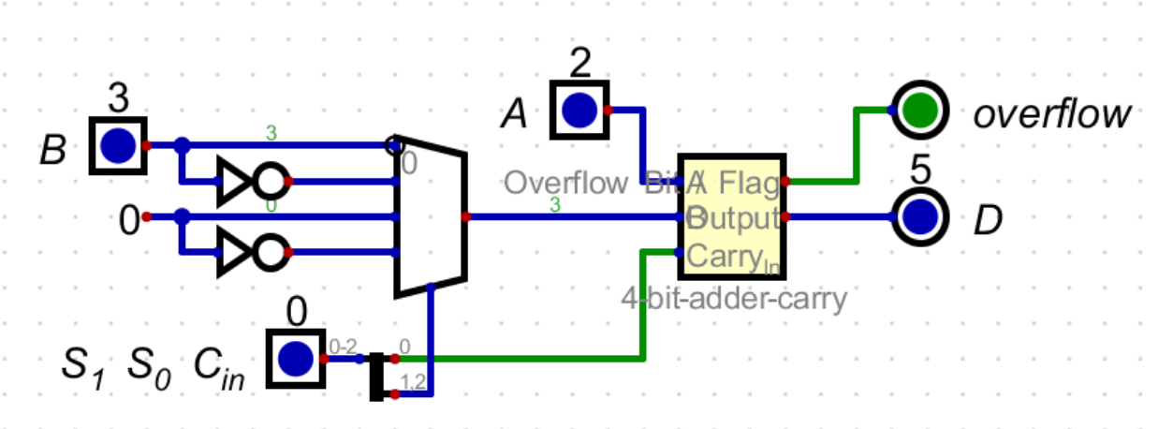

Test 2: Add with Carry

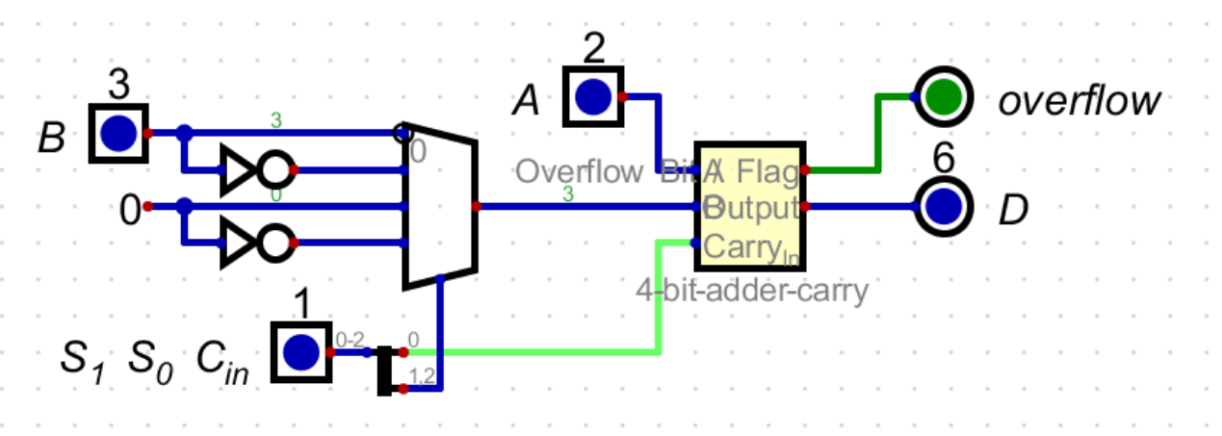

Test 3: Subtract

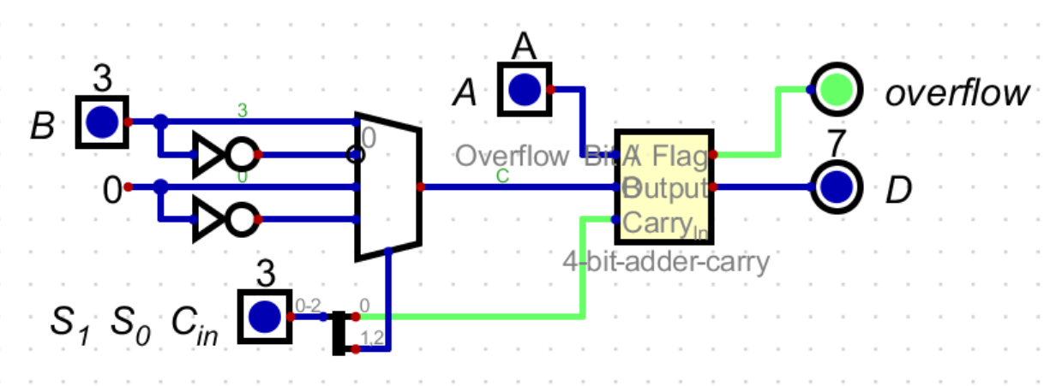

Test 4: Transfer A

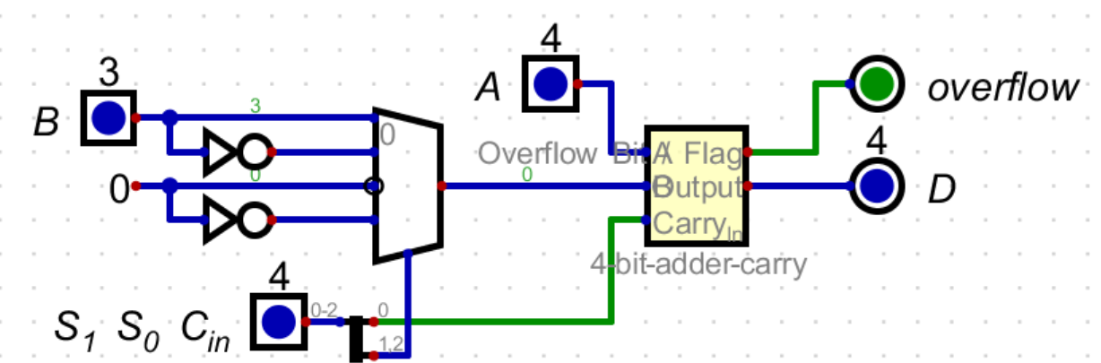

Test 5: Increment A

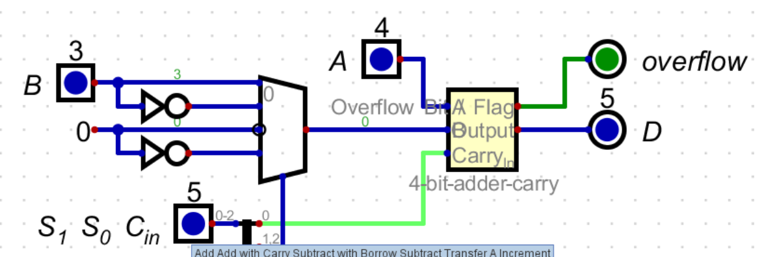

Test 6: Decrement A

